**Lab 5. YES gate**

1. **Parts：**

one 68KΩ Resistor (Blue, Grey, Orange) (**R1 in the diagram**)

one 1KΩ Resistor (Brown, Black, Red) (**R2 in the diagram**)

MPSA20 NPN Transistor

several solid wires

built-in logic probe

1. **NPN Transistor：**

MPSA20 NPN Transistor

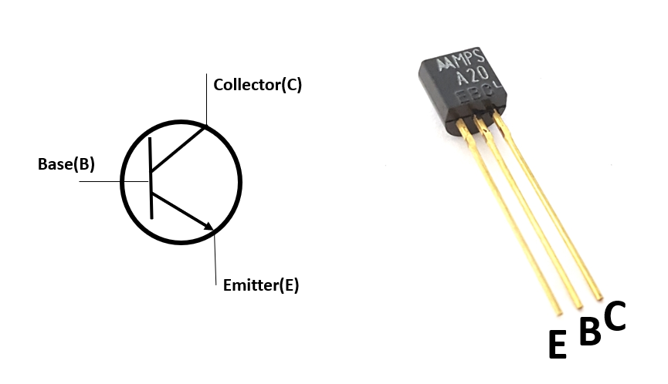

1. **NOT gate：**

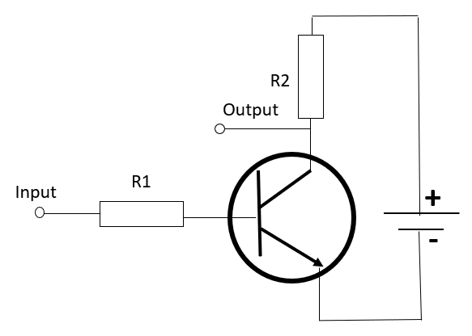

* 1. Connect the input to the positive bus strip as input is 1.

Connect the input to the negative bus strip as input is 0.

* 1. In order to probe the output, touch the tip of logic probe to the bare end of the output wire. See an example below:

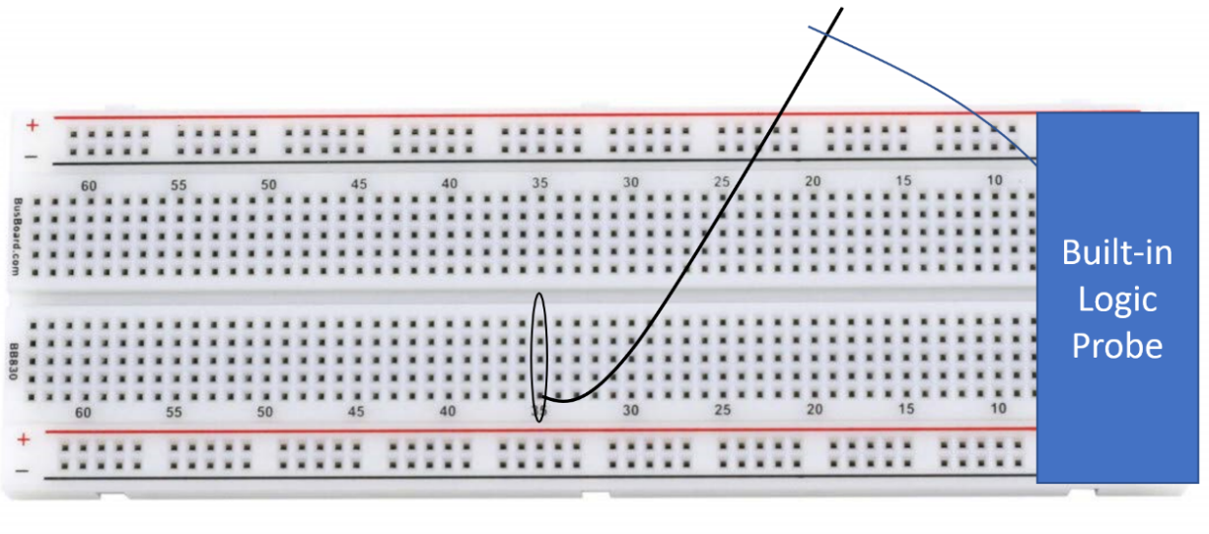

1. **Question:**

You already know how to use transistor to implement the NOT gate. Now think about a way to implement a YES gate, which has a function as input 1 output 1, input 0 output 0. Use exactly same components in NOT gate to build the YES gate.

5.1 **First draw the circuit diagram(in the circuit diagram, indicate where is the input and where is the output) on the paper and show it to me.**

5.2 After I checked it is correct, make the connection on your breadboard.